**ASSIGNMENT 2**

**BINARY SEARCH TREE**

**DUE DATE: WEEK 12 , Friday BEFORE 11.59 PM**

**1.** **OBJECTIVE**

1. To review and strengthen the concept of trees.
2. To practice the recursion techniques.
3. To review different ways of traversing a binary tree.

**2.** **LABORATORY**

You need to work in a group with minimum 3 members and maximum 5 members. You are not allow to work individually or less than 3 members in a group.

**3.** **EQUIPMENT**

Software: The Microsoft Visual Studio 2022. Your programming will only be tested

by the markers using Visual Studio 2022.

**4.** **TASKS:**

The student records are stored in a Binary Search Tree for fast access and searching. This assignment handles:

1. The input of student records from a text file using C++.
2. The storage of student records into a BST.
3. Searching for a student record in a BST.

Use the given source codes in this assignment and add the following functions below:

(a) Write a function **bool readFile(const char *filename, BST *t1)** in main that reads student records from a text file and stores them according to the **student id** in a binary search tree (BST). The function prints to screen the number of student records successfully read. The function return false if file not successfully open and true otherwise. Refer to sample input text file student.txt given. An example of a student record BST is shown in Figure 3.1. Its data in the text file format, **student.txt** is included in the sample textfile folder. In the tree, each node stores a student record. The **key** for the BST is the **id** of each student.

(b) Write a function **bool BST::deepestNodes()**in BST class that finds and prints all the nodes at the deepest level ***(Note: You only need to print the student id for the deepest nodes)***. For example, the deepest nodes of tree1 in Figure 3.2 are 2, 7 and 12 while tree2 has only 21. (**Hint**: You can either use height of tree to look for deepest). Function will return false for empty tree and true otherwise.

1. Write a function **bool BST::display(int order, int source)** in BST class that traverses a BST tree recursively and print the content of every node ***(Note: You need to print all information for each student such as name, id, address, DOB, phone number, course and cgpa)***. The order variable is to specify if user want to print in ascending or descending order according to id. Use order = 1 for ascending and order = 2 for descending. The source variable is used to specify where to print the output. Use source = 1 to print to screen and source = 2 to print to a file name “student-info.txt”. **(Hint: To print in ascending visit left son and then right son. As to print in descending visit right son and then left son.)** Function will return false for empty tree and true otherwise.
2. Provide a function **bool BST::CloneSubtree(BST t1, type item)** that will clone a subtree in t1 where the root of the subtree contain value item. For example, if ***t2.CloneSubtree(t1, 126);*** is called, then the subtree in t1 (t1 is tree in Figure 3.1 and t2 is cloned subtree in Figure 3.1 (a)) where the root contain node 126 will be cloned and store in t2 as shown in Figure 3.1 (a) below. t1 will not change after function call and t2 must be an empty tree before cloning. Display t1 and t2 using preOrderPrint() after function call. ***(Note: You need to print all information for each student such as name, id, address, DOB, phone number, course and cgpa)***. Function will return false if t1 is empty or if item cannot be found. Otherwise return true. If function return false, then no need to display t1 and t2 after function call and just print message “Cannot clone subtree.”
3. Write a function **bool BST::printLevelNodes()** that will print nodes according to level in a BST. Sample output is shown below if Binary Search Tree in Figure 3.1 is calling the function. Function return false for empty tree and true otherwise. ***(Note: You only need to print the student id in the output as shown below)***

**Sample Output:**

**Level 1 nodes: 123**

**Level 2 nodes: 65 126**

**Level 3 nodes: 78 125 234**

1. Write a function **bool BST::printPath()** that will print all the external path in a BST. For example, the output when this function is called to print all the external paths in the BST in Figure 3.1 is shown below. Function return false for empty tree and true otherwise. ***(Note: You only need to print the student id in the output as shown below)***

**Output:**

**Below are all the external paths for the tree:**

**123 65 78**

**123 126 125**

**123 126 234**

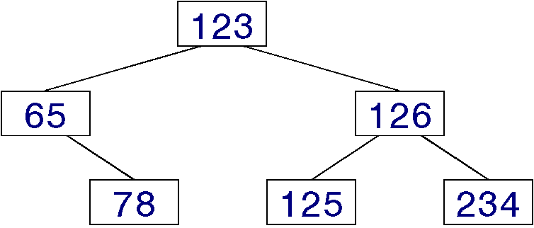

**Figure 3.1: An example of a binary search tree.**

**126**

**125**

**234**

**Figure 3.1(a): An example of the cloned subtree (t2)**

|  |  |  |
| --- | --- | --- |
| tree1  root |  | tree2  root |

**Figure 3.2: Tree1 and Tree2**

(h) Write a function **int menu()** that displays all the above functions (as shown below) for test run.

1. **Read data to BST**
2. **Print deepest nodes**
3. **Display student**
4. **Clone Subtree**
5. **Print Level Nodes**
6. **Print Path**
7. **Exit**

**Although each of the above tasks is to be implemented as a single function, it may be necessary to create additional sub-function(s) to handle portions of the function.**  This is especially true if the original function is too long or contains more than one functionally related group of statements. When you write a function, remember that this function is to work for all possible inputs and not just on your test inputs. You must test for all conditions that might possibly arise; print out appropriate messages as needed.

A text file **student.txt** of student records can be downloaded from WBLE. It is created to assist the development and testing of your program. Its content and even the file name can be changed (while still adhering to the same data format) during grading in order to test the robustness of your program. The objective is to ensure that you do not hardcode your program to work exclusively for the given sample student records.

**5.** **ERROR HANDLING**

You can assume that the input is always correct; thus, no input validation is required.

**6.** **REPORT**

1. This assignment is due according to the due date posted on WBLE. You must do the submission through WBLE. You should create one directory using your name and then copy all your source code files (*.h, and *.cpp) into this directory. You should also provide a readme file (see description below) and all input data files that you test your program. Apart from these, you should not have irrelevant source files in the directory. Compress this directory into a **zip** file and submit only this zip file to WBLE.
2. The readme file should contain the following information:
3. Your name and group member name (if any)
4. Known errors and bugs of your code. (if any)

**7. ACADEMIC HONESTY AND COLLABORATION**

Cooperation is recommended in understanding various concepts and system features. But the actual solution of the assignments, the programming and debugging must be your individual work, except for what you specifically credit to other sources. (Your grade will be based on your own contribution.) For example, copying without attribution any part of someone else’s program is plagiarism, even if you modify it and even if the source is a textbook. You can document the credit to other sources at the start of your program code listing. The University takes acts of cheating and plagiarism very seriously: first time violators may fail the coursework component of UCCD1024. Any wholly (or partly) copied (or being copied) programs will receive zero mark.

**9.** **REFERENCES**

[1] Text and reference books for UCCD1024.

[2] http://msdn.microsoft.com/en-us/visualc/aa336395